**Coupling induction-depression by a decoupled magnon**

Fizaan Khan, Sachin Verma, Bishwanath Bhoi, and Rajeev Singh[1]

*Indian Institute of Technology (BHU) Varanasi*

(Dated: May 15, 2025)

We investigate photon-mediated magnon–magnon coupling between spatially separated Yttrium Iron Garnet (YIG) and Permalloy (NiFe) thin films placed on a planar hexagonal ring resonator. Full-wave simulations performed on CST Studio reveal clear magnon-magnon coupling signatures in the absence of direct dipolar interaction between the magnetic films. Notably, the coupling strength between the hexagonal ring resonator and the Permalloy film increases with the thickness of the YIG film, despite a fixed Permalloy film thickness, suggesting the presence of an indirect interaction channel mediated by resonator photons. To support these findings, we present a theoretical model that accurately reproduces the simulated transmission spectra (|*S*21|) and reveals a nontrivial interdependence between the individual coupling strengths of YIG and Permalloy to the resonator. These results underscore the importance of indirect interactions and potential crosstalk pathways in designing hybrid magnonic systems and scalable quantum architectures, while demonstrating the feasibility of cost-effective, planar configurations for experimental implementation. These insights are valuable for advancing low-loss, coherent information transfer in hybrid quantum devices.

# INTRODUCTION

The advancement of hybrid quantum systems that integrate magnonic and photonic components has emerged as a critical frontier in the pursuit of scalable quantum information processing and next-generation microwave technologies [1, 2]. In such systems, magnons—the quanta of spin waves—interact coherently with microwave photons, enabling unique functionalities such as tunable coupling [—], non-reciprocity [—], and quantum transduction [—]. As these device architectures continue to scale toward nanoscale dimensions [3, 4], the complexity of electromagnetic interactions increases, particularly due to the emergence of indirect or unintended couplings between spatially separated components. Shared photonic modes or circuit environments often mediate these

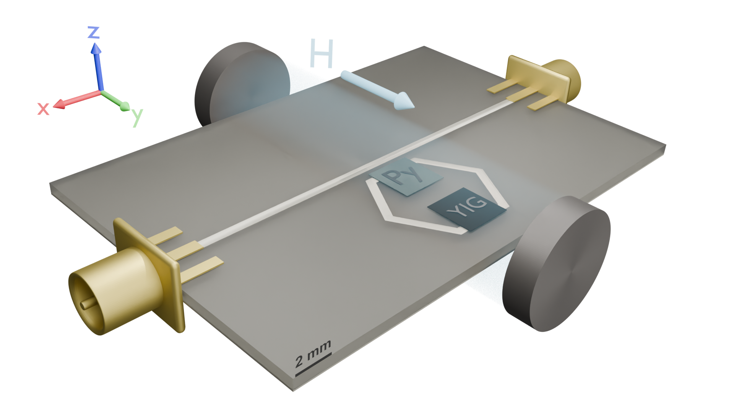

Fig. 1: The experimental setup includes the two magnonic films placed on a pair of opposing sides of a copper hexagon

(the photonic resonator). The ports are plugged into a vector network analyzer to both excite the microstrip line and also measure the transmission spectrum while a

magnetic field is applied along the *y*-direction pictured here.

couplings and can lead to both detrimental crosstalk and useful long-range interactions [5, 6]. Understanding and controlling these mediated interactions is essential for designing scalable hybrid quantum devices that are also coherent and robust.

Material choice plays a crucial role in determining coherence, coupling strength, and scalability in hybrid quantum systems. Yttrium Iron Garnet (YIG), with its low damping and long spin-wave coherence, has emerged as a leading candidate for magnonic quantum circuits [1, 2, 7, 8]. It enables strong and ultrastrong photonmagnon coupling in planar superconducting resonators, with recent studies showing coupling-to-frequency ratios *>* 0.2 [8]. Likewise, lithographically patterned organic ferrimagnets have demonstrated cooperativity values exceeding 103 in the hybrid quantum modes [5], paving the way for their integration with superconducting qubit platforms and enabling circuit quantum electrodynamics (cQED) functionalities within magnon-based architectures. These advances highlight the growing maturity of hybrid photon-magnon coupled (PMC) systems. They underscore the need for deeper exploration into their nontrivial coupling dynamics, particularly those arising from indirect, photon-mediated interactions between spatially separated magnetic elements.

While the Dicke model provides a foundational framework for describing magnon–photon coupling in singlemode systems, it falls short in capturing the complex dynamics of multimode or heterogeneous magnetic systems [9, 10]. Unresolved theoretical and experimental challenges persist, particularly in understanding mediated coupling, the dependence of interaction strength on spin density and spatial configuration, and the role of decoherence in nonlocal systems. Notably, Hyde et al. [11] observed that specific indirectly coupled modes can surpass their directly coupled counterparts in transmission amplitude, highlighting the need to reassess the conventional assumptions surrounding circuit isolation and crosstalk. As previous work suggests that cavity photons can act as effective mediators for long-distance coupling in hybrid architectures [12], we investigate this phenomenon using a hexagonal ring resonator as the coupling platform. It is planar and symmetric: well-suited for probing such mediated interactions and exploring their impact on the coherent dynamics of spatially separated magnetic elements.

This study demonstrates that photon-mediated interactions between a YIG film and a spatially separated Permalloy film, integrated via the resonator, can give rise to measurable magnon-magnon coupling, even in the absence of significant direct dipolar overlap. The observed coupling arises from the nonlocal electromagnetic modes of the resonator, which effectively bridge the two magnetic films. Importantly, the coupling strength is found to depend sensitively on the geometric configuration and electromagnetic response of circuit elements that are otherwise considered independent [–]. Our choice of configuration is in contrast with systems often studied, such as YIG spheres[13–16] and YIG/Permalloy bilayers[17– 19] that carry direct coupling. Notably, this mediated interaction persists even when the individual photonmagnon coupling lies well below the ultrastrong coupling threshold, emphasizing the relevance of indirect pathways in the overall system dynamics [–]. These results suggest that conventional approaches to suppressing crosstalk in magnonic integrated circuits may need to be revised to account for long-range electromagnetic interactions. To model the system, we employ input–output theory[20, 21] instead of the conventional Schrieffer–Wolff transformation[22, 23], allowing us to extract (|*S*21|) and directly compare theoretical predictions with simulation data. The design is intentionally simple and scalable: implemented on a millimeter scale, operable at room temperature. Despite its simplicity, the platform captures essential cavity quantum electrodynamics (cQED) features and offers a promising testbed for investigating mediated coupling in accessible, low-cost quantum device architectures.

# DESIGN AND NUMERICAL MODELING OF THE HYBRID PHOTON-MAGNON SYSTEM

In designing hybrid systems, it is essential to account for the various forms of hybridization and their collective influence on the system’s dynamics. We investigate magnonic interactions in a configuration specifically chosen to minimize direct dipolar coupling. This allows us to isolate and analyze interaction pathways mediated indirectly through a standard bosonic mode, i.e., photons. The simulated hybrid system features the resonator parked near a microstrip line and integrated with the two magnetic films—YIG and Permalloy—mounted on opposite arms of the resonator within a planar geometry, as illustrated in Fig. 1. When a microwave current propagates along the *x*-axis through the microstrip line, it produces a transverse microwave magnetic field

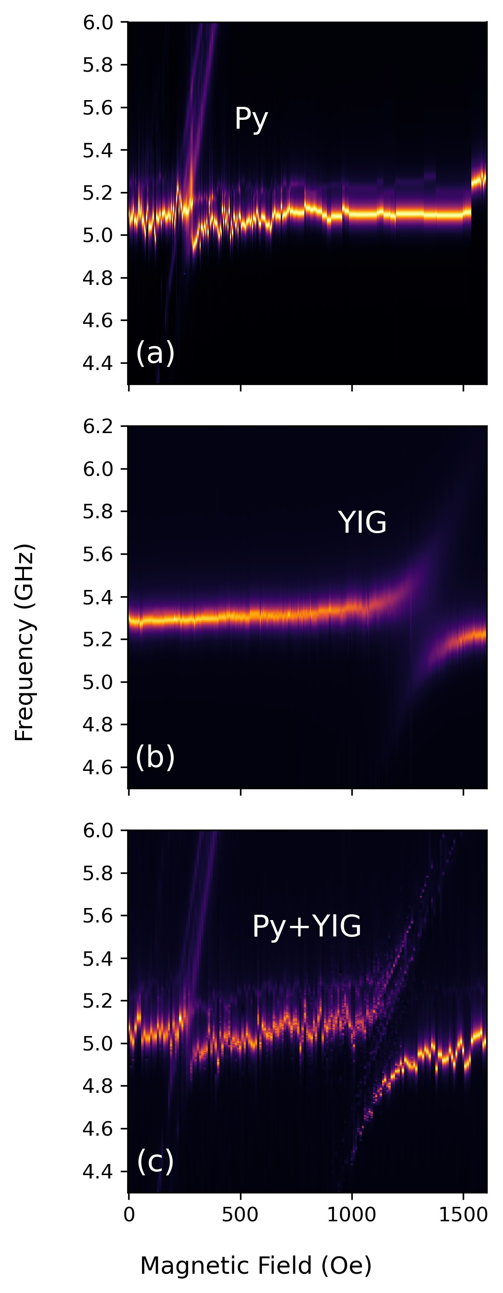

Fig. 2: A comparison of the magnonic coupling strengths of the (a) Permalloy, (b) YIG, and (c) both to the resonator in an indirectly coupled configuration.

that excites the hexagonal resonator (depicted as the silver strip on the substrate). It functions as a parallelLC circuit exhibiting quasi-static resonance. This resonant field, in turn, interacts with the magnetic YIG (black film in Fig. 1) and Permalloy (dirty green film) films placed on the resonator, inducing their respective magnon modes and enabling the probing of respective photon–magnon coupling dynamics. The full-wave electromagnetic solver CST Microwave Studio was employed to simulate individual hybrid configurations: resonator–Permalloy, resonator–YIG, and the combined hybrid system resonator–YIG–Permalloy. The simulations employed standard material parameters for the magnetic films and are listed in Table I. The dimensions of the resonator, the microstrip line, the YIG and Permalloy films are indicated in Table II (for further details, also see Ref. —).

To investigate photon-mediated magnon–magnon coupling, we obtained |*S*21| as a function of microwave frequency (*ω*) under a static external magnetic field (*H*) applied along the *y*-axis at room temperature. Figures 2a, 2b, and 2c show the |*S*21| power spectra on the *ω*–*H* plane for the hybrid systems resonator–Permalloy, resonator–YIG, and resonator–YIG–Permalloy, respectively. In this setup, the photon mode associated with the resonator behaves as a fixed-frequency resonance determined by the geometry of the LC structure. In contrast, the magnon modes in YIG and Permalloy follow the Kittel relation[24], resulting in a resonance that shifts with the applied magnetic field. The strength of photonmagnon coupling is inferred from the degree of avoided level crossing–an established indicator of coherent energy exchange–and is a particularly relevant parameter in applications such as quantum sensing and quantum memory buses [–].

As shown in Fig. 2a, the Permalloy–resonator system exhibits only weak coupling, which is expected due to the metallic nature of Permalloy that introduces higher damping and noise. In contrast, Fig. 2b demonstrates that the YIG–resonator system exhibits strong coupling, attributable to the low damping and high spin-wave coherence of the magnetic material involved. Interestingly, in the combined system (Fig. 2c), the Permalloy mode displays a markedly enhanced coupling signature compared to its isolated behavior, while the YIG coupling appears slightly diminished. This suggests a redistribution of interaction strength facilitated by the resonator’s photon mode, emphasizing the role of photon mediation in enabling effective magnon–magnon interactions between spatially separated magnetic elements.

# THEORETICAL FORMALISM FOR PHOTON MEDIATED MAGNON-MAGNON COUPLING

We developed a microscopic model based on quantum mechanical principles to gain deeper insight into the numerically observed photon-mediated magnon–magnon coupling and quantitatively estimate the corresponding interaction strength. This approach provides a robust framework for describing the coupled dynamics of the system, effectively capturing both direct and indirect interactions. It is readily extended to systems involving multiple coupled quantum harmonic oscillators.

The system Hamiltonian is best understood as a sum of three parts, *H*ˆ = *H*ˆo+*H*ˆmsl+*H*ˆint. The natural Hamiltonian *H*ˆo, is the familiar sum of quantum harmonic os-

cillators,

*H*ˆo*/*ℏ = X *ω*˜*j*ˆ*b*†*j*ˆ*bj* (1)

*j*∈{*r,*1*,*2}

where ˜*ωj* = *ωj* + *iαj* refers to the damped natural frequency of the oscillator for a resonant frequency *ωj* and an intrinsic damping constant *αj*. For the index *j*, we use *r* to denote the photonic resonator and 1 and 2 to denote the Permalloy and YIG magnons respectively.

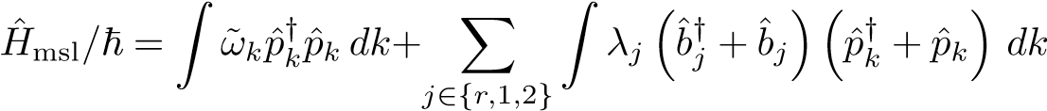We then provide a driving field through a micro stripline, which is assigned the annihilation (creation) operator ˆ*pk* (*p*ˆ†*k*) for the *k*th mode:

(2)

where ˆ*bj* (ˆ*b*†*j*) are the bosonic annihilation (creation) operators. We introduce *λj* to denote the extrinsic damping of each oscillator, i.e., the extent of coupling of the oscillators to the stripline.

The final term in the Hamiltonian is the mutual interaction among all the resonators, photonic and magnonic. The coupling constants *gj* that populate *H*ˆint are of primary interest to us. This part of the Hamiltonian is given by

+ h.c. (3)

and captures the crosstalk between the resonator modes, leading to the observed normal anticrossing in Fig. 2.

The normal anticrossing behaviour is due to real coupling constants in the Hamiltonian[25, 26].

The equations of motion for the three oscillators are readily calculated by a standard procedure[21, 27]. If we set *βi* = 2*πλ*2*i*, the *S*21 parameter for such a system, given by *S*21 = *p*ˆout*/p*ˆin − 1 is[28]

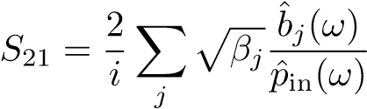 (4)

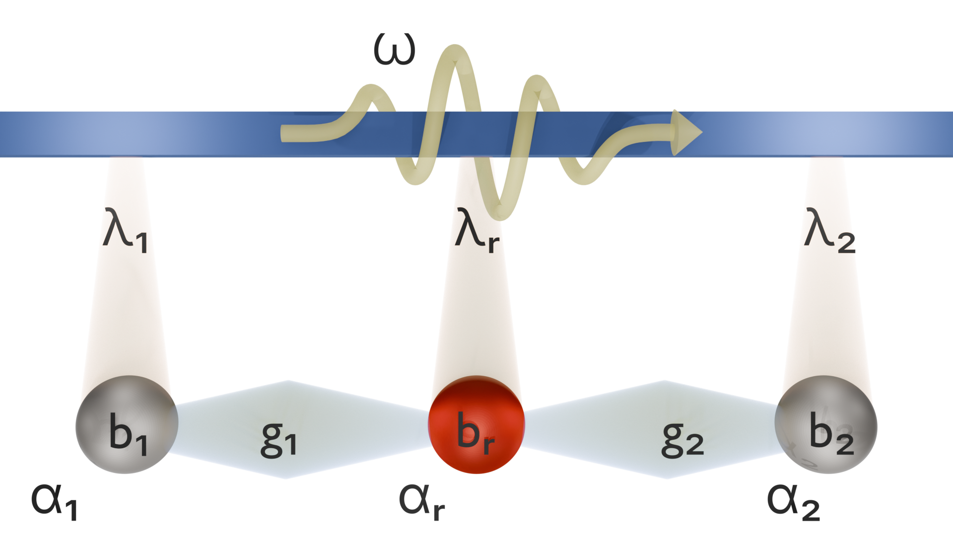

Fig. 3: A cartoon of the model developed for this system. The spheres are bosonic oscillators with creation

(annihilation) operator ˆ*b*†*j*(ˆ*bj*). *αj* and *λj* denote intrinsic and extrinsic damping, coupling the oscillators to the

traveling photon mode. The constants *g*1 and *g*2 denote the coupling of the magnonic cavities to the photonic cavity.

which, rewritten in the form of a matrix

*S*21 = *BT*M−1*B* (5)

where

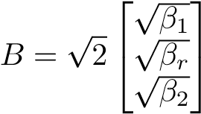 *,*

, where I is the 3 × 3 identity matrix and *H*ˆcoupling is the effective coupling

Hamiltonian[28], that solves the equations of motion for the mode operators, given by

*H*ˆcoupling 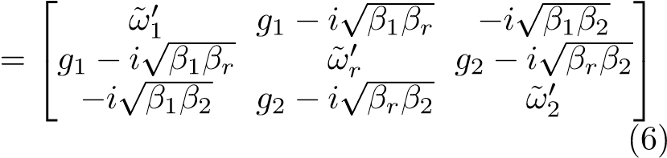

The terms on the diagonal include intrinsic and extrinsic damping terms, in the form ˜*ωj*′ = *ω*˜*j* − *iβj*[28]. Since we are ignoring terms of direct magnon coupling, there are no coupling constants on the edges of the off-diagonal. The parameters *g*1 and *g*2 can be obtained by fitting the model to observations at each *H*.

# DISCUSSIONS

Choosing to exclude terms of direct coupling in the interaction Hamiltonian (3) was far from an arbitrary one. The configuration of the system is such that we observe minimal overlap between the two magnonic films on account of the close-to-planar thin films. This behavior is mirrored by the model, which accurately predicts the *S*21 spectrum in the absence of a direct coupling term.

The coupling constants predictably affect the extent of avoidedness of the avoided crossing for the corresponding magnon (identified by the coupling centers), with greater constants leading to greater avoidedness. In Fig. 4, we show that the observed *S*21 spectrum in the top row against the calculated spectrum in the bottom row captures the same dynamics. Going from left to right, the plotted observations are for increasing thicknesses of the YIG film. Of course, we expect the coupling strength of the YIG to the resonator to increase, but we also note the increasing coupling strength of the Permalloy mode. When the coupling strength of the YIG film in the absence of Permalloy is plotted against its thickness (Fig. 5a), it follows a linear trend. On the introduction of the Permalloy film (Fig. 5b), the intercept is shifted downward, while the Permalloy’s coupling strength is also following a linear trend with non-zero slope. It seems to return an unchanging influence on the coupling strength of the YIG mode. It is clear that any observable interaction between the two magnons in this configuration is mediated through the resonator photon.

This sensitivity to an external parameter of the Permalloy film suggests an indirect dependence on the YIG film that is not captured within the scope of the present model.

It seems to us most appropriate at this point to claim that the quantity *g*1 depends on *g*2 linearly, as is seen in Fig. 5c.

Value

Parameter

YIG Sat. Mag. (4*πM*) 1750 G

YIG Gyromag. Ratio (*γ*) 1*.*76 × 10−2

Permalloy Sat. Mag. (4*πM*) 10900 G

Permalloy Gyromag. Ratio (*γ*) 2*.*94 × 10−3

TABLE I: Material properties to determine resonant frequency of magnons from the Kittel equation[24]:

*ω* = *γ*p*H*(*H* + 4*πM*).

|  |  |
| --- | --- |
| Parameter | Value (mm) |
| Thin film side length (Permalloy & YIG) | 3 |
| Permalloy thickness | 0.02 |
| Resonator outer radius | 4 |
| Resonator inner radius | 3.4 |
| MSL width | 0.57 |
| Substrate length | 30 |
| Substrate width | 20 |
| Substrate thickness | 0.64 |
| Copper thickness (MSL and ground plane) | 0.035 |

TABLE II: Dimensions of the sample.

# CONCLUSIONS

In conclusion, this work bridges the gap between fundamental magnonics and practical device engineering. Elucidating photon-mediated coupling in accessible macroscopic systems provides a roadmap for low-cost classical applications and future quantum technologies requiring precise control over indirect spin-photon interactions. The results underscore the necessity of revisiting cQED models to account for all co-dependent phenomena.

# ACKNOWLEDGEMENTS

The work was supported by the Council of Science and Technology, Uttar Pradesh (CSTUP) (Project Id: 2470, CST, U.P. sanction No: CST/D-1520). B. Bhoi acknowledges support by the Science and Engineering Research Board (SERB) India- SRG/2023/001355. R. Singh acknowledges support from the Council of Science and Technology, Uttar Pradesh (CSTUP) (Project Id: 4482). S. Verma acknowledges the Ministry of Education,

|  |
| --- |
| Fig. 4: Observed (top row) and calculated (bottom row) *S*21 spectra of the system for corresponding thicknesses of YIG. The Permalloy crossing is also seen to widen with a change in YIG thickness.  (a) (b) (c)  Fig. 5: The blue crosses in (a) and (b) represent the coupling strengths of the YIG film to the resonator. The coupling strengths in (a) are for a system that does not include a Permalloy film. Upon introduction of the Permalloy in (b), the  coupling strengths of the YIG have decreased by a fixed amount. The red dots in (b) mark *g*1, the coupling strengths of the Permalloy to the resonator, and blue crosses are *g*2, the coupling strengths of the YIG to the resonator. In (c), we plot the linear relationship between the two coupling strengths, *g*1(*g*2). |

Government of India, for the Prime Minister’s Research Fellowship (PMRF ID-1102628).

# STATEMENTS AND DECLARATIONS

**Funding:** The authors declare that grants or other support were received during the preparation of this manuscript.

**Competing Interests:** The authors hold no competing interests.

**Author Contributions:** All authors contributed to the study’s conception and design. R.S and B.B. led the work and wrote the manuscript with F. Khan. The other co-authors read, commented, and approved the final manuscript.

**Data Availability:** The data supporting this study’s findings are available within the article.

1. B. Bhoi, B. Kim, J. Kim, Y.-J. Cho, and S.-K. Kim, Robust magnon-photon coupling in a planar-geometry hybrid of inverted split-ring resonator and yig film, [Scientific Reports](https://doi.org/10.1038/s41598-017-12215-8) [**7**, 11930 (2017).](https://doi.org/10.1038/s41598-017-12215-8)
2. D. Wagle, A. Rai, M. T. Kaffash, and M. B. Jungfleisch, Controlling magnon-photon coupling in a planar geometry, [Journal of Physics: Materials](https://doi.org/10.1088/2515-7639/ad2984) [**7**, 025005 (2024).](https://doi.org/10.1088/2515-7639/ad2984)
3. J. T. Hou and L. Liu, Strong coupling between microwave photons and nanomagnet magnons, [Phys. Rev. Lett.](https://doi.org/10.1103/PhysRevLett.123.107702) [**123**, 107702 (2019).](https://doi.org/10.1103/PhysRevLett.123.107702)
4. Y. Li, T. Polakovic, Y.-L. Wang, J. Xu, S. Lendinez, Z. Zhang, J. Ding, T. Khaire, H. Saglam, R. Divan, J. Pearson, W.-K. Kwok, Z. Xiao, V. Novosad, A. Hoffmann, and W. Zhang, Strong coupling between magnons and microwave photons in on-chip ferromagnetsuperconductor thin-film devices, [Phys. Rev. Lett.](https://doi.org/10.1103/PhysRevLett.123.107701) [**123**, 107701 (2019).](https://doi.org/10.1103/PhysRevLett.123.107701)
5. Q. Xu, H. F. H. Cheung, D. S. Cormode, T. O. Puel, S. Pal, H. Yusuf, M. Chilcote, M. E. Flatt´e, E. JohnstonHalperin, and G. D. Fuchs, Strong photon-magnon coupling using a lithographically defined organic ferrimagnet, [Advanced Science](https://doi.org/https://doi.org/10.1002/advs.202310032) [**11**, 2310032 (2024).](https://doi.org/https://doi.org/10.1002/advs.202310032)
6. H. Jeon, B. Kim, J. Kim, B. Bhoi, and S.-K. Kim, Anomalous coherent and dissipative coupling in dual photon-magnon hybrid resonators, [Scientific Reports](https://doi.org/10.1038/s41598-024-64315-x) [**14**, 13581 (2024).](https://doi.org/10.1038/s41598-024-64315-x)
7. P. Andrich, C. F. de las Casas, X. Liu, H. L. Bretscher, J. R. Berman, F. J. Heremans, P. F. Nealey, and D. D. Awschalom, Long-range spin wave mediated control of defect qubits in nanodiamonds, npj Quantum Information **3**, [10.1038/s41534-017-0029-z](https://doi.org/10.1038/s41534-017-0029-z) (2017).
8. A. Ghirri, C. Bonizzoni, M. Maksutoglu, A. Mercurio, O. Di Stefano, S. Savasta, and M. Affronte, Ultrastrong magnon-photon coupling achieved by magnetic films in contact with superconducting resonators, [Phys. Rev. Appl.](https://doi.org/10.1103/PhysRevApplied.20.024039) [**20**, 024039 (2023).](https://doi.org/10.1103/PhysRevApplied.20.024039)
9. I. Golovchanskiy, N. Abramov, V. Stolyarov, A. Golubov, M. Y. Kupriyanov, V. Ryazanov, and A. Ustinov, Approaching deep-strong on-chip photon-to-magnon coupling, Physical Review Applied **16**, [10.1103/physrevapplied.16.034029](https://doi.org/10.1103/physrevapplied.16.034029) (2021).
10. R. D. McKenzie, M. Libersky, D. M. Silevitch, and T. F. Rosenbaum, Theory of magnon polaritons in quantum ising materials, [Phys. Rev.](https://doi.org/10.1103/PhysRevA.106.043716) [A](https://doi.org/10.1103/PhysRevA.106.043716) [**106**, 043716 (2022).](https://doi.org/10.1103/PhysRevA.106.043716)
11. P. Hyde, L. Bai, M. Harder, C. Match, and C.-M. Hu, Indirect coupling between two cavity modes via ferromagnetic resonance, [Applied Physics Letters](https://doi.org/10.1063/1.4964602) [**109**, 152405 (2016).](https://doi.org/10.1063/1.4964602)
12. V. L. Grigoryan and K. Xia, Cavity-mediated dissipative spin-spin coupling, [Phys. Rev.](https://doi.org/10.1103/PhysRevB.100.014415) [B](https://doi.org/10.1103/PhysRevB.100.014415) [**100**, 014415 (2019).](https://doi.org/10.1103/PhysRevB.100.014415)
13. R. G. E. Morris, A. F. van Loo, S. Kosen, and A. D. Karenowska, Strong coupling of magnons in a yig sphere to photons in a planar superconducting resonator in the quantum limit, [Scientific Reports](https://doi.org/10.1038/s41598-017-11835-4) [**7**, 11511 (2017).](https://doi.org/10.1038/s41598-017-11835-4)
14. X. Zhang, C.-L. Zou, L. Jiang, and H. X. Tang, Cavity magnomechanics, [Science Advances](https://doi.org/10.1126/sciadv.1501286) [**2**, e1501286 (2016),](https://doi.org/10.1126/sciadv.1501286) [https://www.science.org/doi/pdf/10.1126/sciadv.1501286.](https://arxiv.org/abs/https://www.science.org/doi/pdf/10.1126/sciadv.1501286)
15. J. Bourhill, N. Kostylev, M. Goryachev, D. L. Creedon, and M. E. Tobar, Ultrahigh cooperativity interactions between magnons and resonant photons in a yig sphere, [Phys. Rev.](https://doi.org/10.1103/PhysRevB.93.144420) [B](https://doi.org/10.1103/PhysRevB.93.144420) [**93**, 144420 (2016).](https://doi.org/10.1103/PhysRevB.93.144420)
16. Dilawaiz, S. Qamar, and M. Irfan, Entangled atomic ensemble and an yttrium-iron-garnet sphere in coupled microwave cavities, Physical Review A **109**, [10.1103/physreva.109.043708](https://doi.org/10.1103/physreva.109.043708) (2024).
17. J. Inman, Y. Xiong, R. Bidthanapally, S. Louis, V. Tyberkevych, H. Qu, J. Sklenar, V. Novosad, Y. Li, X. Zhang, and W. Zhang, Hybrid magnonics for shortwavelength spin waves facilitated by a magnetic heterostructure, [Phys. Rev. Appl.](https://doi.org/10.1103/PhysRevApplied.17.044034) [**17**, 044034 (2022).](https://doi.org/10.1103/PhysRevApplied.17.044034)
18. O. A. Santos and B. J. van Wees, Magnon confinement in an all-on-chip yig cavity resonator using hybrid yig/py magnon barriers, [Nano Letters](https://doi.org/10.1021/acs.nanolett.3c02388) [**23**, 9303 (2023),](https://doi.org/10.1021/acs.nanolett.3c02388) pMID: 37819876.
19. Y. Xiong, Y. Li, M. Hammami, R. Bidthanapally, J. Sklenar, X. Zhang, H. Qu, G. Srinivasan, J. Pearson, A. Hoffmann, V. Novosad, and W. Zhang, Probing magnon–magnon coupling in exchange coupled Y3Fe5O12/Permalloy bilayers with magneto-optical effects, [Scientific Reports](https://doi.org/10.1038/s41598-020-69364-6) [**10**, 12548 (2020).](https://doi.org/10.1038/s41598-020-69364-6)
20. D. Walls and G. J. Milburn, *Quantum Optics* (Springer Science & Business Media, 2007).
21. K. K. Shrivastava, A. Sahu, B. Bhoi, and R. Singh, Unveiling photon-photon coupling induced transparency and absorption, [Journal of Physics D Applied Physics **57**, 465305 (2024).](https://doi.org/10.1088/1361-6463/ad6613)
22. V. Grigoryan and J. Xiao, Dynamical spin-spin coupling of quantum dots, [Europhysics Letters](https://doi.org/10.1209/0295-5075/104/17008) [**104**, 17008 (2013).](https://doi.org/10.1209/0295-5075/104/17008)
23. J. R. Schrieffer and P. A. Wolff, Relation between the anderson and kondo hamiltonians, [Phys. Rev.](https://doi.org/10.1103/PhysRev.149.491) [**149**, 491](https://doi.org/10.1103/PhysRev.149.491)

[(1966).](https://doi.org/10.1103/PhysRev.149.491)

1. C. Kittel, On the theory of ferromagnetic resonance absorption, [Phys. Rev.](https://doi.org/10.1103/PhysRev.73.155) [**73**, 155 (1948).](https://doi.org/10.1103/PhysRev.73.155)
2. N. R. Bernier, L. D. To´th, A. K. Feofanov, and T. J. Kippenberg, Level attraction in a microwave optomechanical circuit, [Phys. Rev.](https://doi.org/10.1103/PhysRevA.98.023841) [A](https://doi.org/10.1103/PhysRevA.98.023841) [**98**, 023841 (2018).](https://doi.org/10.1103/PhysRevA.98.023841)
3. A. Metelmann and A. A. Clerk, Quantum-limited amplification via reservoir engineering, [Phys. Rev. Lett.](https://doi.org/10.1103/PhysRevLett.112.133904) [**112**, 133904 (2014).](https://doi.org/10.1103/PhysRevLett.112.133904)
4. J. W. Rao, Y. P. Wang, Y. Yang, T. Yu, Y. S. Gui, X. L. Fan, D. S. Xue, and C.-M. Hu, Interactions between a magnon mode and a cavity photon mode mediated by traveling photons, [Phys. Rev.](https://doi.org/10.1103/PhysRevB.101.064404) [B](https://doi.org/10.1103/PhysRevB.101.064404) [**101**, 064404 (2020).](https://doi.org/10.1103/PhysRevB.101.064404)
5. K. K. Shrivastava, M. D. Ketkar, B. Bhoi, and R. Singh, [Emergence of coupling induced transparency by tuning purely dissipative couplings](https://arxiv.org/abs/2409.12577) (2024), [arXiv:2409.12577 [quant-ph].](https://arxiv.org/abs/2409.12577)

1. rajeevs.phy@iitbhu.ac.in